**32. Introduction**

**# Create chart**

--- helm create firstchart

--- **note** – by default, it will use nginx chart.

**# List the firstchart structure**

--- tree

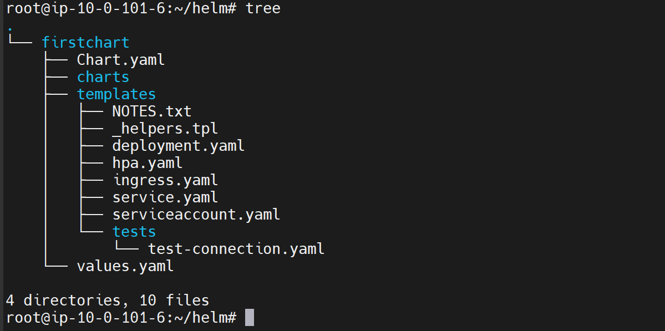

--- **note** – helm will create these default structure for us.

--- **chart.yml** - The chart dot yaml file is where the meta data about the chart exists.

--- **charts** – for now this is empty, but if this chart depends on any other charts to get its job done, then those charts will be pulled and stored inside this charts folder.

--- **template folder** - the template folder is important folder. Here we have all the templates like **deployment.yaml**, **Ingress.yaml**, **Service.yaml** that are used to render the Kubernetes Manifest to package and deploy this project later to Kubernetes cluster.

--- **values.yml** - This guy contains all the values, the default values that should go into. template yaml files, which are under the templates folder, we can override these values when we install a particular Package.